Facilities Project Request (FPR)
11-5-18
Through the AUP
Facilities Project Requests are submitted in two stages:
- Feasibility Study – Section 1
  - Submitted to the Facilities Director for review and input
  - Send electronically to Loren.Homquist@gcccd.edu
  - Due on June 1

- Finalized Facilities Project Request (FPR) – Section 2
  - Feasibility Study must be completed first
  - Submitted to the Grossmont College Facilities Committee
  - Send to CPIE through the AUP
  - Due on October 1
-------------------------------------------------------------------------------------------------------------------------------------
Facilities Project Request (FPR)
Feasibility Study
Objectives of the Feasibility Study:
- Provide programs the opportunity to envision projects in a draft form.

- Determine the appropriateness of the request for review by the Facilities Committee (it may more appropriately handled by a capital campaign or routine maintenance).

- Garner support from the Facilities Director who will provide input and suggestions for the final submission of the FPR to the Facilities Committee.

Required Signatures for the Feasibility Study (Obtain before the due date of October 1)
- Submitter – Program Chair or Supervisor
- Manager – Division Dean or Director
- Vice President – Of the requestor’s department
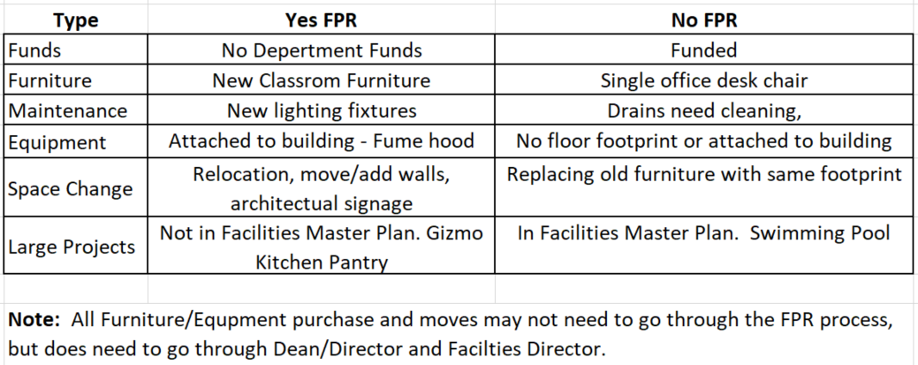
EXAMPLES of FPR projects
- Not sure if project should go through the FPR process? Email loren.holmquist@gcccd.edu

Facilities Project Request (FPR)
11-5-18
Section 1 - Feasibility Study
Date: FPR#: (Office Use)
Requestor’s Name:
Phone:
May we contact you in the summer if questions arise? Yes No
If yes, please provide contact information if different from above.
If no, please provide name and phone number of summer contact:
Department/Program:
Project Name:
(Brief phrase identifying need such as “Foreign language lab space expansion”)

Project Location (building/room number):

- Project Description (Please be specific and thorough. You may attach a diagram or sketch of the proposed project to help illustrate your project. Word count suggestion: 100 to 500 words:

- Project Category (check all that apply)

Technology: audiovisual, computers, data, software or phones
Construction: building or structure modification or new construction
Electrical, mechanical, plumbing
Landscape or outdoor project
Furniture or space utilization:
Reconfiguration of furniture
Reconfiguration of the layout of a shared space
New furniture (For individual offices, a different process is used: please see you dean.)

- Safety/Health Concern Is your project an OSHA concern? (Occupational Safety and Health Administration)
Yes No unsure
Comments:
- FMO Impact (Will your project require extensive labor or time from Facilities, Maintenance, & Operations staff?).
Yes No unsure
Comments:
- Student Impact (Briefly explain how your project affects students, including in terms of academic success, accessibility, retention, equity, and guided pathways). Word count suggestion: 100 to 500 words:

- Campus Impact (List the other departments, programs, or services that may be impacted by this project).

- How many students will benefit from your project?

- Project Support

Is your project previously recognized in the college planning processes? Check all that apply.
Yes No Unsure Recommendation from Program Review Committee (Link)
Yes No Unsure Department or Program Annual Plan.
Yes No Unsure College or District Facilities Master Plan (Link).
Yes No Unsure (QUALIFY WHICH) Strategic Plan (Link)
Yes No Unsure Educational Master Plan (Link)
Yes No Unsure Student Success and Equity (Link)
- Budget
Estimated Cost (if known):
Potential/Recommended funding source:

- Time-Line
Ideal target date:
Consequence if target date unmet:
- Signatures (Please secure signatures before submitting your Feasibility Study to the Facilities Director. Feasibility Studies without signatures will be returned. This may jeopardize the success of the study.)

Chair/Supervisor (print name & signature): Date
Dean/Director (print name & signature): Date
Vice President (print name & signature): Date

