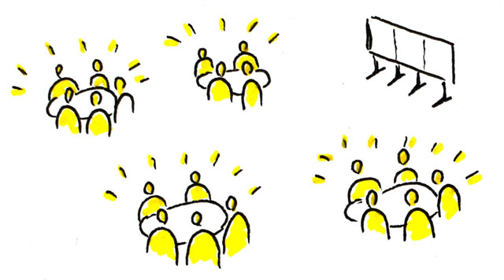
Over the past few years, in classrooms, various meetings, and all-college forums, Grossmont College has discussed student outcomes data, completed surveys on student engagement, and conducted student focus groups.
Based on these many discussions and a recent review of those same data by a college workgroup (as part of our participation in the Achieving the Dream Initiative [ATD]) three primary areas of focus related to student success rose to the top:
For Course Completion:
- Professional development
(in-classroom strategies)
- Mentoring
- Supplemental Instruction
- Early alert
For Basic Skills Sequence Completion:
- High school – college curriculum alignment
- Course acceleration
For Student Engagement:
- Professional development
- Mentoring
In order to most effectively impact these measures in a positive way, we need to throw our collective efforts behind the implementation of a few targeted, research-based, high-impact practices that can affect the success of larger numbers of students.

These include:
DRAFT
Fall 2015

Getting Involved
What's Next?
Based on common elements of the college student success plans (Basic Skills, Student Success & Support Program, and Student Equity) and our Title V grant, the results of the World Café event, and data review, the ATD workgroup is recommending the following three best practices for broad implementation over the next year:
- Student Engagement Practices
- Course Acceleration
- Supplemental Instruction

SHARE YOUR THOUGHTS
To share your thoughts on these recommendations or for more information, contact:
Lida.Rafia@gcccd.edu x7770
In September 2015, approximately 80 Grossmont College faculty, staff, administrators, and students participated in a robust "World Café" conversation on student success. The purpose of the conversation was to allow time for participants to: 1) contribute their thinking and experience; 2) listen and understand others; and 3) connect ideas for student success. Following the event, the ATD workgroup compiled the themes as follows:
- Engagement/college connection matters – inside and outside the classroom
- Meeting the needs of students and empowering them
- Course acceleration needed – for basic skills sequence completion
- Need intrusive counseling
- Embedded tutoring/supplemental instruction – for basic skills and targeted classes
- Professional Development for faculty and staff – student engagement, equity pedagogy
Equity Gaps in Successful Course Completion
(ATD first-time cohort data)
Race/Ethnicity (top three enrolled groups)
White – 75%
Hispanic Latino – 65%
African American/Black – 56%
Gender
Female – 71%
Male – 69%
Foster Youth – 60%
(compared to non FY @ 70%)
Age
30-49 years – 77% 20-24 years – 67%
25-29 years – 72% < 20 years – 70%

Completion of Basic Skills Sequence
(complete transfer course within three years)
(ATD first-time cohort data)
English
Overall – 35%
ESL
Overall – 63%*
Math
Overall – 14%

NOTE: Approx. 75% of first-time students assess at below transfer level in English and/or math.
* - Student Success Scorecard data
What we know
Student Engagement
What's going well (CCSSE data)
- 59% of students reported asking questions in class
- 70% reported they analyzed basic elements of idea, experience, or theory

What's not: (faculty vs. student answers)
Students: Faculty Student
- Ask questions 87% 59%
- Referred to tutoring 46% 10%
- Work with other
students outside class 63% 38%

Achieving the Dream – Impacting Student Success
What can we do?

