

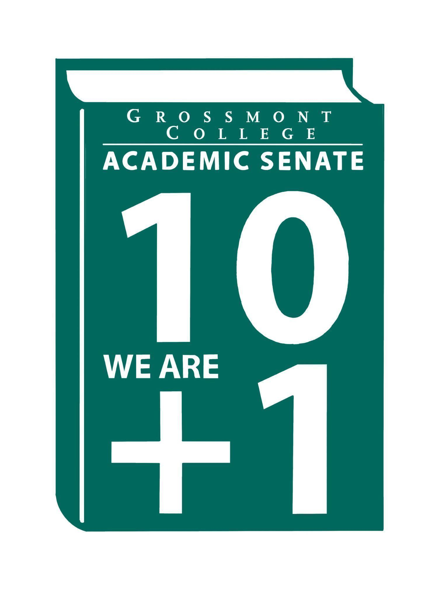

Meeting Minutes of the Academic Senate
Grossmont College
February 2, 2026
11:00 am-12:20 pm
ATTACHMENTS
1 | Call to Order 11:08 am
2 | Public Comment:  Michelle Crooks.-Explained the cancellation of in-person English classes due to low enrollment and lower success rates in online formats. Discussed strategies to promote the on-campus experience for the English department, including staff partnerships and targeted flyers.  Michael Perez.-Shared key dates for the semester:  Feb 15-Last day to drop full term classes without W  March 28-last day to apply for pass/no pass  May 2-last day to drop full term class with W  Also reviewed available student resources such as tutoring and student services programs.
3 | Approval of minutes from December 1, 2025.  VOTE: Minutes approved with no objections  Motion: J.Calo/D. Aceves
4 | Approval of Agenda  VOTE: Agenda approved with no objections  Motion: J. Calo/M.Larter
5  5.1  5.2  5.3  5.4 | Announcements  Welcome Natalye Harpin as the interim VP of AS  Introduced Natalye as new interim Vice President of Academic Senate for the rest of the semester.  Call-out for New Programs  An email was sent this morning. Follow-up responses regarding bachelor’s degree call-outs will be sent. For any questions, please contact Dr. Sampson, who can direct you to the appropriate resource.  SOC Meeting Request Form  Use the form to submit requests and to ensure that all voices are heard. Please reach out if you’d like anything to be added to the form.  ASCCC Webinars  Several engaging webinars are being held, you can find information on Google site.
6  6.1  6.2  6.3  6.4  6.5  6.6 | President’s Report  Joint AS GC/CC Retreat Update  A successful retreat was held last week. A follow-up form was sent to those who were unable to attend. Asked how current experiences can be leveraged to develop strategies moving forward.  Call-out for (New Programs/BDP)  An email was sent this morning, and we look forward to reviewing the applications.  Distance Education-Coordinator Position  Adelle Roe will be stepping down at the end of Spring semester. Expressed appreciation for her service.  Update on Public Safety (GC/CC/AFT will collaborate on researching existing CCC’s Police Departments)  During a district presentation, a discussion was held on public safety. It was decided not to wait for a district-level executive decision regarding options. The group appears to be moving forward with Option A to establish Grossmont’s own police department. A call-out from the task force will be conducted to discuss research, finance, etc.  Faculty Hiring/Interim Counseling Dean (Spring 2026)  The deadline is this week; please submit your name for consideration. Seeking someone in this role who will help address and improve the needs of counseling colleagues.  Immigration-(How can we serve our students)  A protocol has been shared outlining what faculty and staff should do if ICE were to come on campus. Please remember that your safety and the safety of students is the top priority. Concerns were raised about the safety of having all students and faculty gather in a small area during evacuations for school shootings. Opportunities to support the education of immigrant students were shared.
7  7.1  7.2  7.3  7.4 | Information Items  Constitution & Bylaws (1st Read)  Based on other colleges’ Constitution & Bylaws. Please find in attachments to make changes and recommendations.  Revised Resolution (ASGC)-Ensuring Precalculus Choice at Grossmont College after AB 1705 (2nd Read)  Please review so we can move to an action item.  AP/BP 5050 Student Success and Support Program (Please Review)  BP 5040 Student Records, Directory Information, and Privacy (Please Review)
8  8.1 | Presentations  Faculty Representatives Reports  - Senate Committees  - Participator Governance Committees
9  9.1 | Action Items  Resolution Affirming 10+1 Primacy  Conversation was had regarding the method of counting votes, QR code vs. hand counting.  Motion: D. Aceves/J. Vanden Eynden  45 yes, 4 abstain, 0 against  Resolution passes
10  10.1  10.2 | Vice-President’s Report/Unfinished Business-Tabled  Participatory Governance (open active recruitment)  Will be sending out email regarding updates department division representatives.  Senators (Updated dept/division reps)
11  11.1  11.2  11.3 | Future Agenda Items  High level overview of BDP Process  Will be a review updating this information.  Review of Senate Rules  Review Plans for Senate Retreat
12 | ASCCC Webinars, Announcements, and Resources  February 12, 12:00-1:00pm Planting the Seeds of Systemic Change: Incorporating IDEAA in Faculty Evaluations  February 19, 10-11:00 am-Realize the Pride: Panel Discussion with CCC Faculty Equity Practitioners  February 19, 10-11:00 am Realize the Pride: Panel Discussion with CCC Faculty Equity Practitioners  February 19, 10-11:00 am Realize the Pride: Panel Discussion with CCC Faculty Equity Practitioners  February 20, 2-3:00 pm Effective AI Prompting for Educators  February 20, 2-3:00 pm Effective AI Prompting for Educators  February 25, 3-4:30 pm The Counselor’s Role in a Changing Landscape: Technology, Equity, and Vision 2030  Academic Freedom Resource Guide is intended to support faculty with information to ensure they know their roles, rights, and responsibilities in the use of academic freedom; includes links to a Playlab.ai bot trained to support research on academic freedom
13 | Adjournment:  VOTE: Motion to adjourn: D. Aceves/R. Garcia  The meeting adjourned at 12:08.  Next meeting: March 3, 2026.

SIGN IN
2/2/2026 10:51:06 | Robin Sepúlveda | Senator | CDEFS
2/2/2026 10:51:52 | Michele Perchez | Senator | Biology
2/2/2026 10:52:20 | Shawn Hicks | Guest | Math & Sciences Division
2/2/2026 10:52:58 | Jennifer Vanden Eynden | Senator | Math
2/2/2026 10:53:01 | Nemie Capacia | Senator | Math
2/2/2026 10:54:05 | Sébastien Cormier | Senator | Physics
2/2/2026 10:56:01 | Tate Hurvitz | Guest | CPIE
2/2/2026 10:56:28 | Randy Abshier | Senator | ESNH
2/2/2026 10:56:43 | Angela Feres | Senator | ESBS
2/2/2026 10:57:09 | Natalye Harpin | Senate Officer (Only SOC) | Ethnic Studies
2/2/2026 10:57:30 | Adelle Roe | Guest | English
2/2/2026 10:58:16 | Brian keliher | Senator | Bus adm
2/2/2026 10:58:45 | Hadeel Yaqoub | Senate Officer (Only SOC) | ESBS
2/2/2026 10:59:07 | Michael Perez | Senator | EOPS/CARE
2/2/2026 10:59:16 | Philip Bell | Senator | CSIS
2/2/2026 10:59:50 | Patrice Braswell | Senator | A.R.C.
2/2/2026 11:00:24 | Ryan Gray | Senator | VAH
2/2/2026 11:00:33 | Denise Schulmeyer | Senator | Communication
2/2/2026 11:00:58 | Ricardo crespo | Senator | Political economy
2/2/2026 11:01:20 | Regina Garcia | Senate Officer (Only SOC) | Cardiovascular Technology
2/2/2026 11:01:45 | Gina Sorensen | Senator | Dance
2/2/2026 11:02:45 | June yang | Senate Officer (Only SOC) | Phil and relg
2/2/2026 11:02:47 | Daniel Gough | Senator | ASL
2/2/2026 11:02:57 | Martin Larter | Senator | Chemistry
2/2/2026 11:03:11 | Lynn Keane | Senator | BOT
2/2/2026 11:03:15 | Lara Braff | Senator | Behavioral Sciences/ANTH
2/2/2026 11:03:54 | Scott Therkalsen | Senator | Earth Science
2/2/2026 11:04:00 | Michelle Crooks | Senator | Esbs/english
2/2/2026 11:04:21 | Holly Reed | Senator | OTA
2/2/2026 11:04:46 | Felicia Kalker | Senator | Library
2/2/2026 11:04:59 | Debbie Rose | Senator | Respiratory
2/2/2026 11:05:44 | Khalid Alkhurie | Guest | World languages
2/2/2026 11:05:53 | Selene Miles | Senator | Biology
2/2/2026 11:06:22 | Jamie Gould | Senator | ASL
2/2/2026 11:06:34 | Jeff Waller | Senator | Mathematics
2/2/2026 11:06:43 | Jeanette Calo | Senator | MCOM
2/2/2026 11:07:02 | Joel Castellaw | Senator | Communication
2/2/2026 11:07:15 | Joan Ahrens | Guest | VPAA
2/2/2026 11:07:32 | Victoria Curran | Senator | Communication
2/2/2026 11:07:50 | Diana Ramirez | Senate Officer (Only SOC) | Counseling
2/2/2026 11:08:13 | Carey Flores | Senator | Respiratory therapy
2/2/2026 11:08:19 | Wendy Cruzado | Guest | Counseling
2/2/2026 11:08:58 | Dr. Vanessa Fountain | Guest | ALC
2/2/2026 11:08:58 | Sarah Moore | Senator | Transfer Center
2/2/2026 11:09:17 | Agustin Albarran | Guest | ESBS Division
2/2/2026 11:09:17 | Natalia Aylett | Senator | ESL
2/2/2026 11:09:18 | Jonathan Martin | Senator | History
2/2/2026 11:09:20 | Kelly | Senator | AOJ
2/2/2026 11:09:23 | Rebecca Handley | Senator | RESP
2/2/2026 11:09:24 | Nancy Saks | Guest | AHN
2/2/2026 11:09:27 | Julie Schanze | Guest | Mental health
2/2/2026 11:09:31 | Karen Caires | Senator | ESNH
2/2/2026 11:09:37 | Brodney Fitzgerald | Senator | Physics and Astronomy
2/2/2026 11:09:40 | Denise Aceves | Senator | Counseling
2/2/2026 11:09:48 | Elisabeth Burke | Senator | Philosophy and Religious Studies
2/2/2026 11:09:51 | Judd Curran | Senator | Earth Sciences
2/2/2026 11:10:12 | James foran | Senator | Culinary
2/2/2026 11:11:25 | Patricia Chow | Senator | CTE/Business
2/2/2026 11:11:26 | Ruth Navarro | Senator | WLD
2/2/2026 11:14:57 | Diana Vance | Senator | Chemistry and science
2/2/2026 11:14:58 | Megan Konold | Senator | ESNH
2/2/2026 11:23:32 | Amanda Clay | Senator | Orthopedic Tech program/department
2/2/2026 11:24:59 | Julio Soto | Guest | Sociology
2/2/2026 11:27:54 | Gareth Davies-Morris | Senator | VAH
2/2/2026 11:32:27 | Natalie Ray | Senator | Counseling

