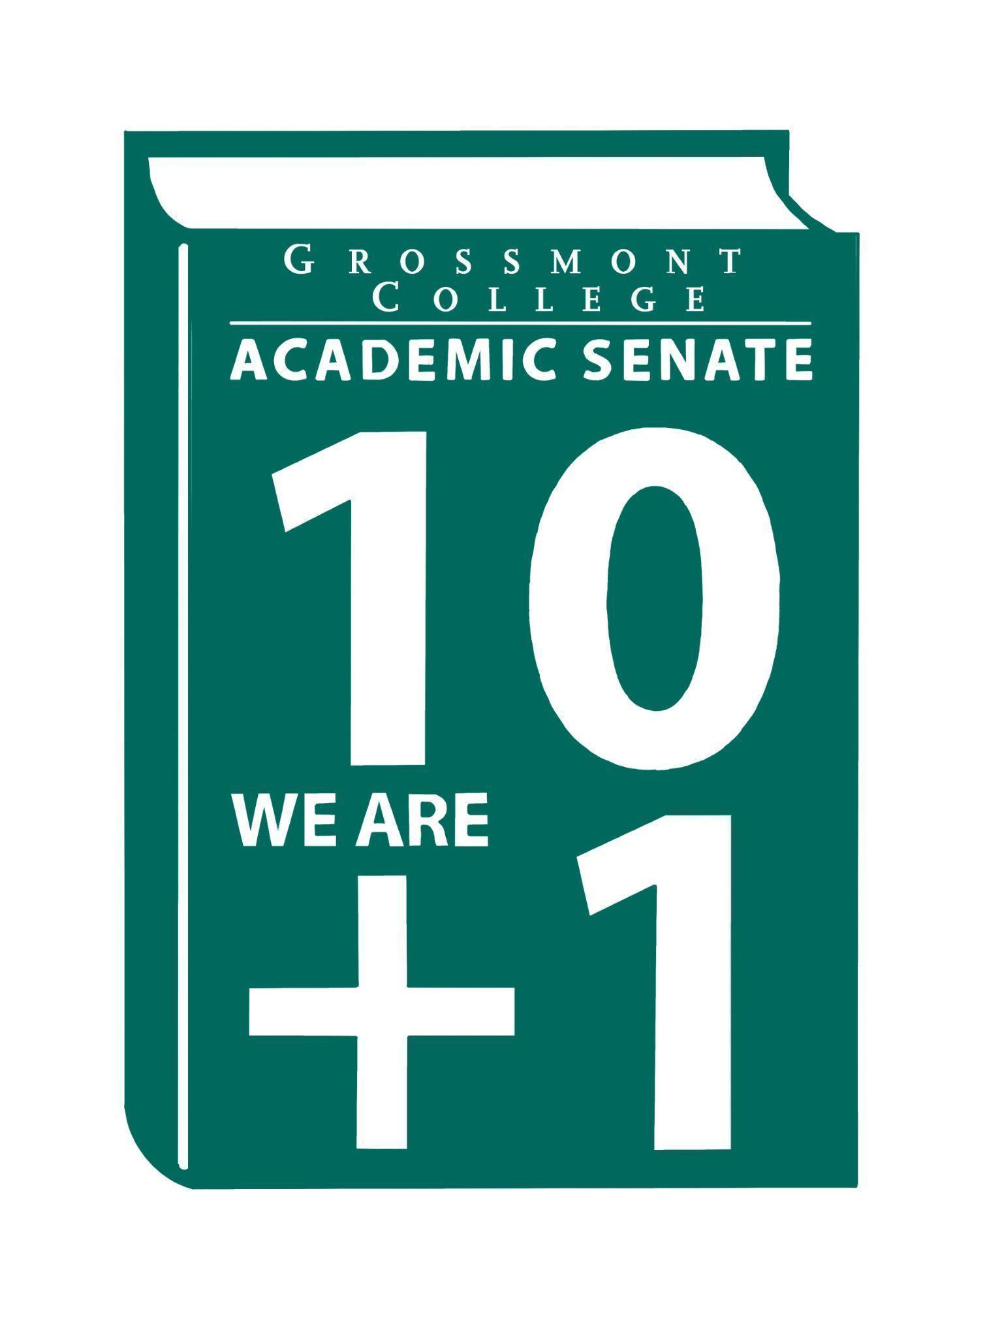
Purpose: Recommended Process for Academic Senate Review of the Constitution and By-Laws
The Academic Senate Constitution and By-Laws serve as the foundational documents that guide the structure, governance, and operations of the Senate. To ensure these documents remain current, relevant, and reflective of the Senate’s work and institutional needs, a regular and transparent review process is essential. This regular review process reflects the Academic Senate’s commitment to maintaining clear, effective, and responsive governance structures.
Review Cycle
The Academic Senate shall conduct a comprehensive review of its Constitution and By-Laws on a two-year cycle during the Spring semester. This timeline allows for thoughtful reflection, meaningful faculty engagement, and alignment with evolving institutional practices, governance structures, and regulatory requirements.
Review Process
- Review Workgroup
  - At the beginning of the Spring semester in each review year, the Senate President shall review the Constitution and By-Laws Review Workgroup.
  - The workgroup should include Senate Officers, Senators, and additional faculty members as appropriate to ensure broad representation.
- Scope of Review
  - The workgroup shall review the Constitution and By-Laws in their entirety.
  - The review shall assess clarity, accuracy, alignment with current Senate practices, compliance with Title 5 and district policies, and the effectiveness of governance structures.
- Faculty Input and Transparency
  - Proposed revisions shall be shared with the full Senate and the broader faculty for review and feedback.
  - Opportunities for discussion shall be provided through Senate meetings, open forums, or written feedback mechanisms.
- Recommendation and Approval Process
  - Following the review and incorporation of feedback, the workgroup shall present recommended revisions to the Academic Senate.
  - Any proposed amendments shall follow the established procedures outlined in the Constitution and By-Laws for Senate approval and, where applicable, ratification by the faculty.
- Implementation and Documentation
  - Once approved, revisions shall be formally incorporated into the Constitution and By-Laws.
  - The updated documents shall be made publicly available and archived for institutional recordkeeping.
Special Consideration Outside of the Regular Cycle
While the comprehensive review will occur on a two-year cycle during the Spring semester, the Academic Senate recognizes that circumstances may arise requiring more immediate revisions. Should revisions be necessary outside of the established review cycle, such items shall be placed on the Academic Senate agenda for special consideration. These revisions shall follow the same principles of transparency, faculty input, and formal approval as outlined above.
Through intentional and periodic review, the Senate ensures that its foundational documents continue to support faculty voice, participatory governance, and the advancement of educational excellence and equity.

