

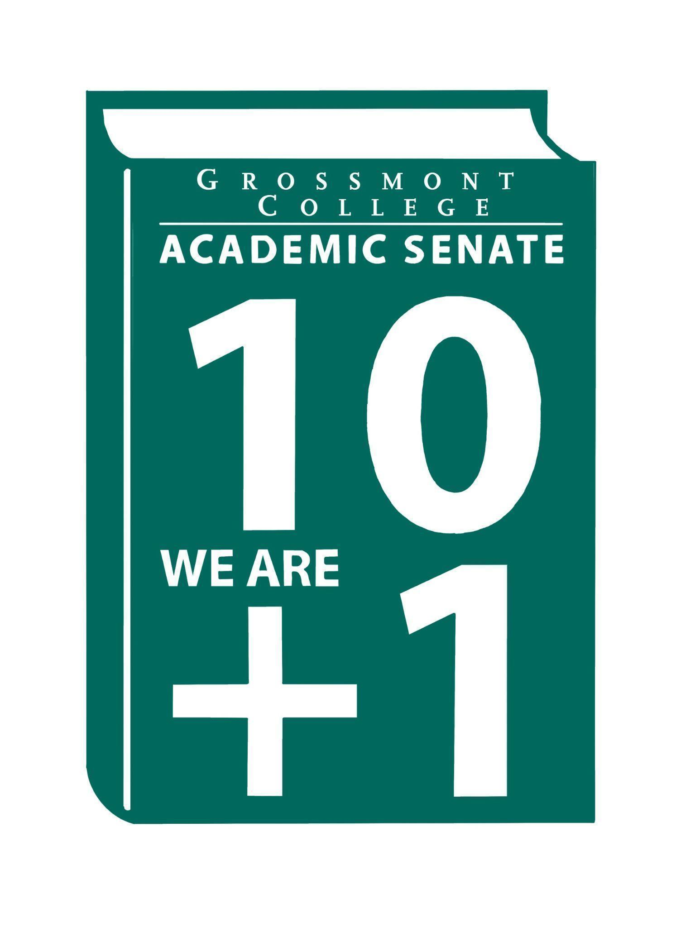

Meeting Minutes of the Academic Senate
Grossmont College
December 1, 2025
11:00 am-12:20 pm
ATTACHMENTS
1 | Call to Order 11:10 am
2 | Public Comment:
3 | Approval of minutes from November 17, 2025.  VOTE: Minutes approved with no objections  Motion: J. Waller/J. VandenEynden
4 | Approval of Agenda  VOTE: Agenda approved with no objections  Motion: J. Waller/J. Calo
5  5.1  5.2  5.3  5.4  5.5 | Announcements  ADSOC Agenda request (document in the attachment folder)  Faculty Hiring Committee-Volunteers needed (Child Development Faculty)  A new position has opened. Please submit names of interested volunteers. Additional information will be sent out today. We need two internal members and one external member for the committee.  Child Development Center-Family Night  Follow-up email will be sent regarding how Academic Senators can contribute.  Joint AS Senate Retreat (Hosted @ Cuyamaca 1/29/26 10-12pm)  Reassigned Timeline (Still pending review by the District led taskforce)  Interim VP will update.
6  6.1  6.2  6.3  6.4  6.5 | President’s Report  Feasibility Process (New Programs, Discontinuance, BDP)  - CSIS Update  CSIS recommendations made for the process. Hoping to get an update by Spring semester.  - Respiratory Therapy Program  Follow-up to Respiratory Therapy Bachelor’s program. Concerns were brought up regarding the Senate's purpose is to ensure the feasibility process is being followed.  Sabbatical Applications (Updated Processing Timeline)  The applications have been forwarded to the chairs, followed by the dean and VPs. We will check back to confirm that all signatures are in place. Our goal is to finalize the process before winter break.  CCCCO guidance for implementing new Title 5 Regulations of the Flexible Calendar (Timeline-March 16th)  The State Chancellor's office has submitted a memorandum regarding Title 5 changes. Please review this information.  AI Taskforce-District Committee Update  Taskforce met last week. There is a Canvas container developed by the taskforce. Once updates are made, this will be made more accessible.  Camera Signage on Campus (Draft Protocol in the attachments)  Signage for placement of cameras with additional cameras facing roadways. More robust conversation regarding safety can be had after implementation of cameras.
7  7.1  7.2  7.3  7.4 | Information Items  Resolution Affirming 10+1 Primacy (2nd Read)  Reminder this is a recommendation for the chancellor to recognize 10+1 primacy. Comment was made to change language to reflect effective participation.  Resolution (ASGC)-Ensuring Precalculus Choice at Grossmont College after AB 1705 (1st Read)  Revision was made to document. Requesting feedback.  Motion to table 7.3 and 7.4 to give more time to Chancellor and Vice Chancellor  J. Waller/J. Calo  5.3.3.1 AFT Contract recommended language (Edits)  BP 4060 Delineation of Functions Agreements (Please Review)  BP 5070 Student Attendance Accounting Manual (Please Review)
8  8.1  8.2 | Presentations  Facilities Representatives Reports  - Senate Committees  - Participatory Governance Committees  - Professional Advancement Committee (Submitted Written Report)  Chancellor’s Office on Safety & Security Policing Options  A document was shared outlining the background of the Reimagining Public Safety initiative and explaining why the current safety model is no longer effective. Recent incidents were reviewed, including faculty being targeted by social media groups and an attempted murder on campus in which employees had to intervene.  A proposed new safety model was presented: the creation of a Chief Safety Officer position supported by two sergeants, with a minimum staff of six officers. This model would ensure coverage for evening events, and officers would be armed in some capacity. The proposal is based on the Cerritos College model.  A conversation was had regarding the budget for implementing these positions as well as the hiring process.
9  9.1 | Action Items  Academic Senate One-Year Vision
10  10.1  10.2 | Vice-President’s Report/Unfinished Business-Tabled  Participatory Governance (open active recruitment)  Positions will be opening up for various committees.  Senators (Updated dept/division reps)
11  11.1  11.2  11.3 | Future Agenda Items  Evan Wiring & Michael Stewart-CPL-Tabled  Review of Bylaws  Review of Rules
12 | ASCCC Webinars, Announcements, and Resources  November 2025 Rostrum  ASCCC Newsletter for November 7, 2025  ASCCC Newsletter for November 20, 2025  ASCCC Newsletter for October 23, 2025  ASCCC OERI November 2025 Newsletter  Academic Freedom Resource Guide is intended to support faculty with information to ensure they know their roles, rights, and responsibilities in the use of academic freedom; includes links to a Playlab.ai bot trained to support research on academic freedom
13 | Adjournment:  VOTE: Motion to adjourn: D. Aceves/S. Working  The meeting adjourned at 12:27.  Next meeting: February 2, 2026.

SIGN IN
12/1/2025 10:46:25 | Katie Banville | Senator | Theatre Arts
12/1/2025 10:47:24 | Sébastien Cormier | Senator | Physics and astronomy
12/1/2025 10:56:49 | Adam Deutsch | Senate Officer (Only SOC) | English
12/1/2025 10:57:35 | Philip Bell | Senator | CSIS
12/1/2025 10:58:37 | Robin Sepulveda | Senator | CDEFS
12/1/2025 10:59:12 | Malia Molina | Senator | Art History / VAH
12/1/2025 10:59:19 | Carey Flores | Senator | Respiratory therapy
12/1/2025 10:59:22 | James Foran | Senator | Culinary/CTE
12/1/2025 11:00:03 | Diana Vance | Senator | Chemistry and Science
12/1/2025 11:00:16 | Patrice Braswell | Senator | A.R.C.
12/1/2025 11:00:16 | Ricardo crespo | Senator | Political economy
12/1/2025 11:02:05 | Gina Sorensen | Senator | Dance
12/1/2025 11:02:55 | Judd Curran | Senator | Earth Sciences
12/1/2025 11:03:22 | JeffcWaller | Senator | Mathematics
12/1/2025 11:03:23 | Jamie Gould | Senator | Asl
12/1/2025 11:03:40 | Rebecca Handley | Senator | RESP
12/1/2025 11:03:40 | June Yang | Senate Officer (Only SOC) | PHIL & RELG
12/1/2025 11:03:41 | Susan Working | Senator | Math
12/1/2025 11:03:43 | Jonathan Martin | Senator | History
12/1/2025 11:03:51 | Lynn Keane | Senator | BOT
12/1/2025 11:04:35 | Joel Castellaw | Senator | Communication
12/1/2025 11:04:37 | Julie Schanze | Senator | Mental health
12/1/2025 11:04:40 | Debbie Rose | Guest | Respiratory Therapy
12/1/2025 11:04:42 | Lara Braff | Senator | ANTH/behavioral sciences
12/1/2025 11:05:07 | Sosha Thomas | Senate Officer (Only SOC) | BOT
12/1/2025 11:05:29 | Natalia Aylett | Senator | English as a Second Language
12/1/2025 11:06:26 | Hau Nguyen | Senator | CSIS
12/1/2025 11:06:47 | Michael Bacon | Senator | Psychology
12/1/2025 11:06:56 | Gareth Davies-Morris | Senator | VAH
12/1/2025 11:07:12 | Jeanette Calo | Senator | MCOM
12/1/2025 11:07:59 | Joyce Fries | Guest | Occupational Therapy Assistant
12/1/2025 11:08:02 | Selene Miles | Senator | Biology
12/1/2025 11:08:04 | Holly Reed | Senator | OTA
12/1/2025 11:08:30 | Jennifer Vanden Eynden | Senator | Math
12/1/2025 11:08:45 | Victoria Curran | Senator | Communication
12/1/2025 11:08:54 | Elisabeth Burke | Senator | Philosophy and Religious Studies
12/1/2025 11:08:59 | Alan Traylor | Senate Officer (Only SOC) | English
12/1/2025 11:09:13 | Ryan Gray | Senator | Vah
12/1/2025 11:09:39 | Karen Caires | Senator | Exercise Science, Nutrition and Health
12/1/2025 11:10:29 | Felicia Kalker | Senator | Library
12/1/2025 11:10:35 | Denise Aceves | Senator | Counseling
12/1/2025 11:11:35 | Diana Ramirez | Senate Officer (Only SOC) | Counseling
12/1/2025 11:14:48 | Gabrielle gosselin | Guest | CalWORKs
12/1/2025 11:18:25 | Patricia Chow | Senator | Cte/business
12/1/2025 11:18:44 | Martin Larter | Senator | Chemistry
12/1/2025 11:27:47 | Michele Perchez | Senator | Biology
12/1/2025 11:32:31 | Raymond Funk | Senator | Mathematics

